COSC 4333 Group Project
Fall 2024
Due: 10:00am, Dec. 2, 2024 (Monday)
This is a group project. Each group can have up to 3 students. Please form the group yourself. Both students in the same group will receive the same grade for this project. You can also do it individually.
The projects must be implemented on Unix/Linux platforms. You may use either C/C++ or Java.
Project Description
In this project, students are required to implement a multi-threaded chat room service. The system will have one (multi-threaded) chat server, several chat rooms, and multiple chat clients. Socket interface is used to implement network communications.
You may start with the provided client.c and server.c program (please download them from the folder socket programming). They list the basic program structures of the client and server using socket programming.
Chat Server
There is only one chat server, whose IP address is known. It listens on a well-known port to accept JOIN request from the client. The JOIN request should contain the chat room name (suppose the name of the chat room is first) the client wants to join.
1. If the chat room first does not exist, the chat server creates a new thread (use pthread_create()) to serve for this chat room first. first will have a new port. It will receive the chat messages for chat room first, and forward the messages to all chat clients who are already in first.
2. If the chat room first already exists, the chat server can make the client join the chat room directly.
The following slide shows the basic structure of a multithreaded server. You may add more information (for example, information of chat rooms, client information in each chat room, etc.)
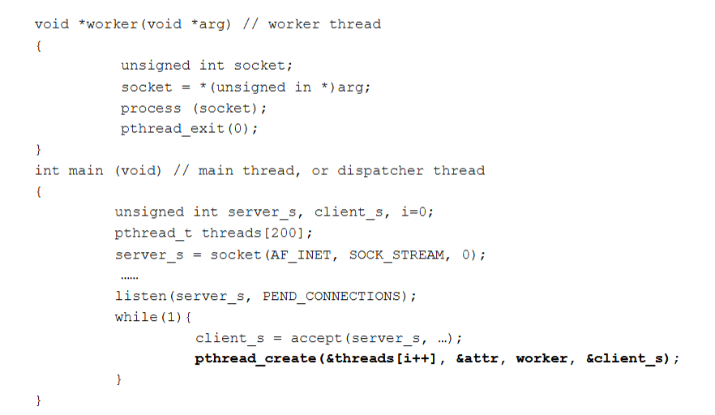
When a client wants to leave a chat room, the client sends a LEAVE request. When there is no client in a chat room anymore, the corresponding chat room should be deleted.
Chat Client
Different clients can run on different machines. When a client wants to join a specific chat room, he sends a JOIN request to the well-known port of the chat server. When a client wants to leave a specific chat group, he can send a LEAVE request.

Deliverables:
- Source code of client-side (ChatroomClient.c) and server-side (ChatroomServer.c) programs;
- README file containing instructions on how to compile and run your client and server-side programs;
- Report which briefly present how you design and implement your programs
- A simple demo about how your chat client and server interact. Please use a short video clip to record your demo and illustrate how the client log into the char server how clients in the same chat room chat, and how a client leaves a chat room. Please use two chat rooms for demo purposes.
- Only one student from each group needs to submit the project. All students from the same group will receive the same grade for the project.

